ASSIGNMENT-2
NAME: M.Sanjana
GROUP: CSE-AIML
COURSE: AI Assisted Coding
ENROLL NO: 2503A52709

Task 1: Statistical Summary for Survey Data

- Scenario:
You are a data analyst intern working with survey responses stored as numerical lists.

- Task:
Use Google Gemini in Colab to generate a Python function that reads a list of numbers and calculates the mean, minimum, and maximum values.

- Expected Output:
  - Correct Python function
  - Output shown in Colab
  - Screenshot of Gemini prompt and result
Prompt:
Generate a Python function for a survey data analysis task. The function should take a list of numbers as input and calculate the mean, minimum, and maximum values. Provide the Python code, an example input list, and the expected output. Make the code simple and suitable for running in Google Colab.
Code:
def statistical_summary(numbers):
mean = sum(numbers) / len(numbers)
minimum = min(numbers)
maximum = max(numbers)

return mean, minimum, maximum

# Survey data
data = [10, 20, 30, 40, 50]

mean, minimum, maximum = statistical_summary(data)

print("Mean:", mean)
print("Minimum:", minimum)
print("Maximum:", maximum)
Output:
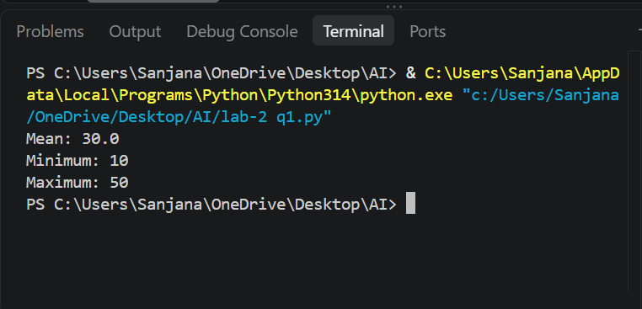

Task 2: Armstrong Number – AI Comparison

- Scenario:
You are evaluating AI tools for numeric validation logic.

- Task:
Generate an Armstrong number checker using Gemini and GitHub Copilot.
Compare their outputs, logic style, and clarity.

- Expected Output:
  - Side-by-side comparison table
  - Screenshots of prompts and generated code
Prompt:
Generate a Python program to check whether a given number is an Armstrong number. Use simple and clear logic. Provide the complete code and show the output for an example number such as 153. The code should be suitable for running in Google Colab or VS Code.
Code:
def is_armstrong(num):
digits = str(num)
power = len(digits)
total = 0

for digit in digits:
total += int(digit) ** power

return total == num

num = 153

if is_armstrong(num):
print(num, "is an Armstrong number")
else:
print(num, "is not an Armstrong number")
Output:
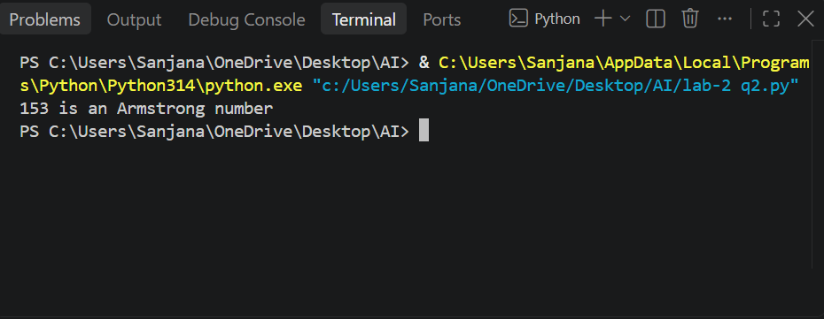

Task 3: Leap Year Validation Using Cursor AI

- Scenario:
You are validating a calendar module for a backend system.

- Task:
Use Cursor AI to generate a Python program that checks whether a given year is a leap year.
Use at least two different prompts and observe changes in code.

- Expected Output:
  - Two versions of code
  - Sample inputs/outputs
  - Brief comparison
Prompt:
Create a Python function to check whether a given year is a leap year. The function should return True for a leap year and False otherwise. Test it with multiple years including 2024, 1900, and 2000.
Code:
def is_leap_year(year):
if year % 400 == 0:
return True
elif year % 100 == 0:
return False
elif year % 4 == 0:
return True
else:
return False

years = [2024, 1900, 2000]

for year in years:
if is_leap_year(year):
print(year, "is a leap year")
else:
print(year, "is not a leap year")
Output:
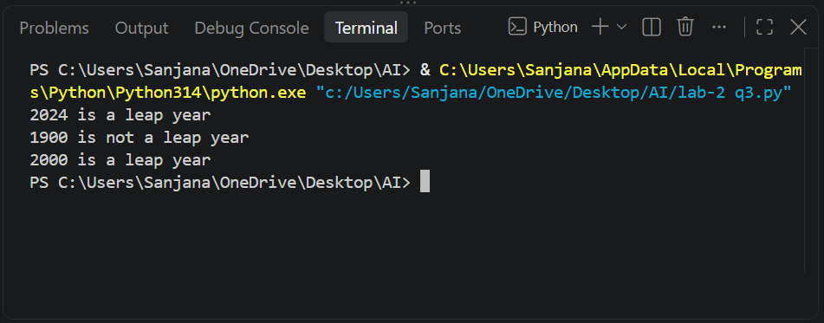

Task 4: Student Logic + AI Refactoring (Odd/Even Sum)

- Scenario:
Company policy requires developers to write logic before using AI.

- Task:
Write a Python program that calculates the sum of odd and even numbers in a tuple, then refactor it using any AI tool.

- Expected Output:
  - Original code
  - Refactored code
  - Explanation of improvements
Prompt:
Write a Python program to calculate the sum of odd and even numbers in a tuple. First provide a simple original solution using a for loop and if-else conditions. Then refactor the same program using a shorter and cleaner approach. Provide both the original and refactored code, their outputs, and briefly explain the improvements made.
Code:
numbers = (1, 2, 3, 4, 5, 6, 7, 8, 9, 10)

odd_sum = 0
even_sum = 0

for num in numbers:
if num % 2 == 0:
even_sum += num
else:
odd_sum += num

print("Sum of odd numbers:", odd_sum)
print("Sum of even numbers:", even_sum)
Output:
